Introduction and Getting Started

* Cloud computing is model for enabling convenient , on demand access to shared pool of configurable computing resource(Network, servers, storage, applications and services)
* AWS is global infrastructure service | EC2 is virtual server.
* If you need to buy a server for very long time choose reserved instances but if you need for short time go for on demand instances due to cost issue.

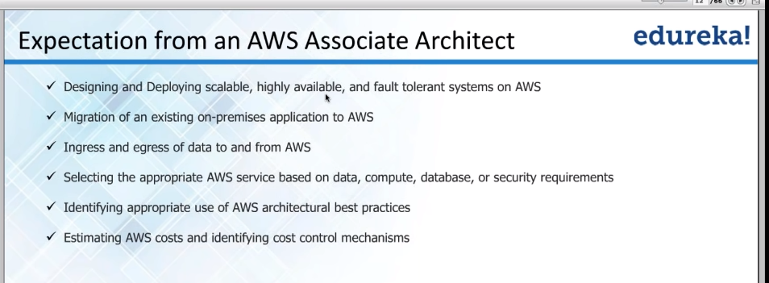

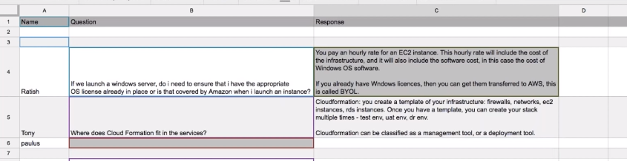

**What are the differences between AWS and Docker?**

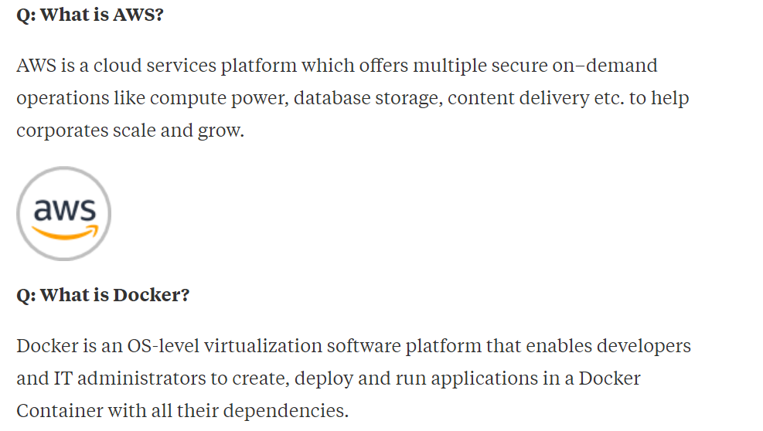

**Amazon web services** (AWS ) are a set of services offered by Amazon. It falls under Platform as a service (PaaS). You can build your entire infrastructure using services offered by AWS.

For example, you can use elastic compute cloud ( EC2 ) instead of your physical services and also scale up and down in a matter of minutes.

**Docker** is a virtualization technology primarily developed using Linux kernel and is also available for Windows images now. In simple terms using docker you can install and run multiple flavours of linux ( Ubuntu, Fedora etc ) and they will use dockers resource isolation feature to run all the system on the same time. So you can simultaneously run web server on ubuntu, database on Fedora all on the same physical host.

Docker enables true independence between applications and infrastructure and developers by providing a layer of abstraction over the physical hardware.

Main services offered by AWS.

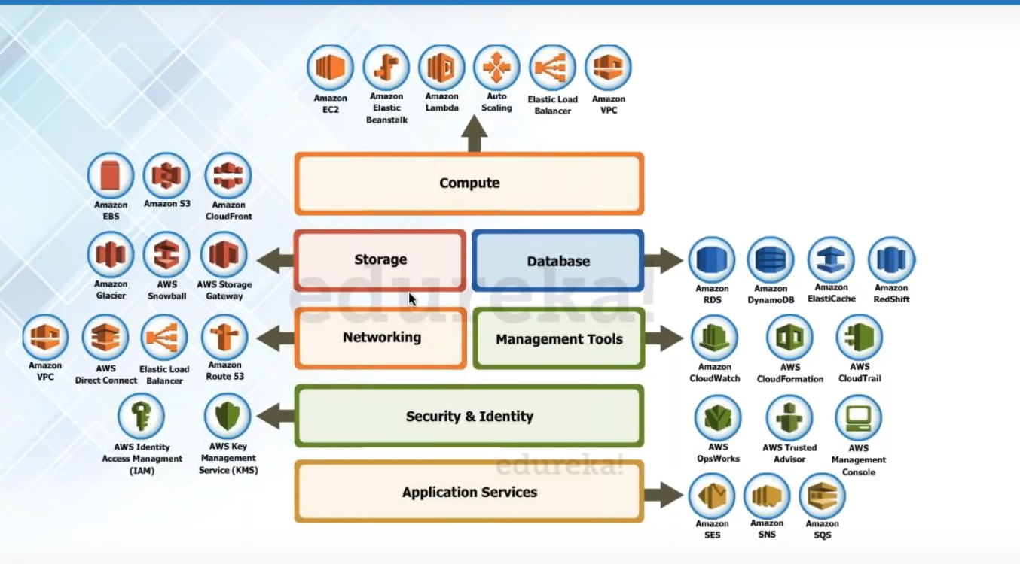

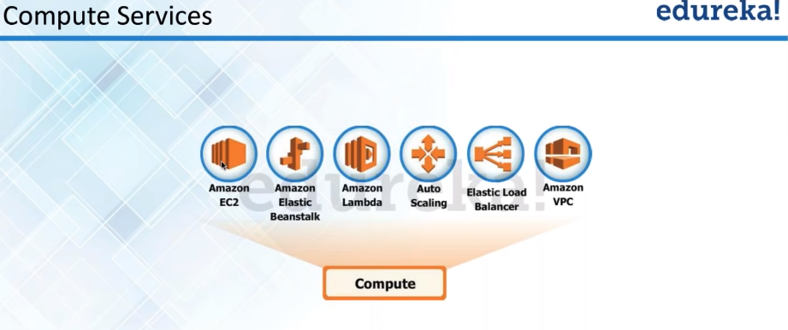

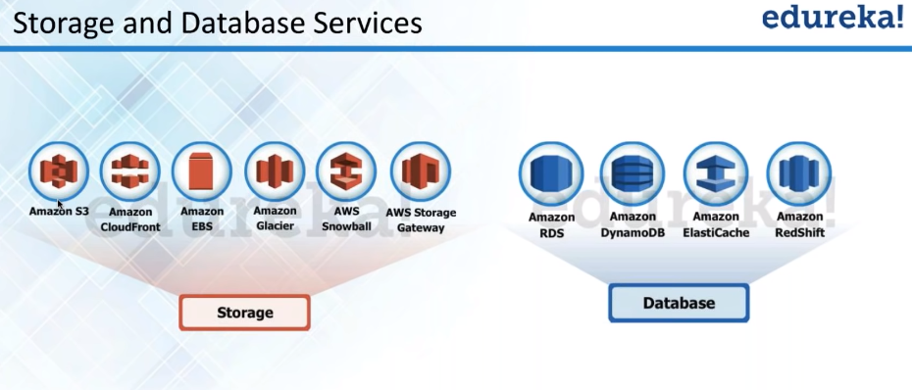

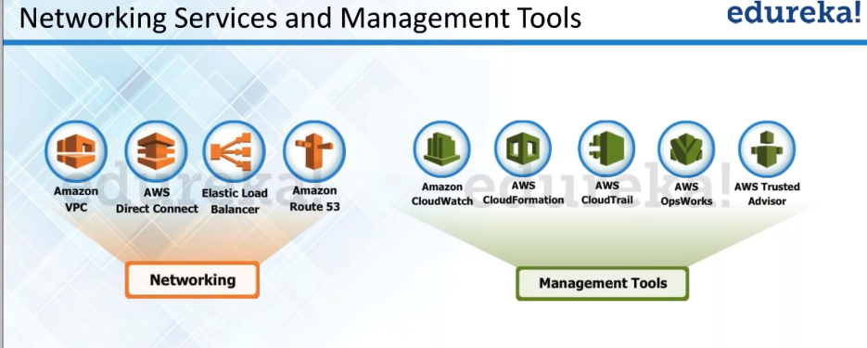

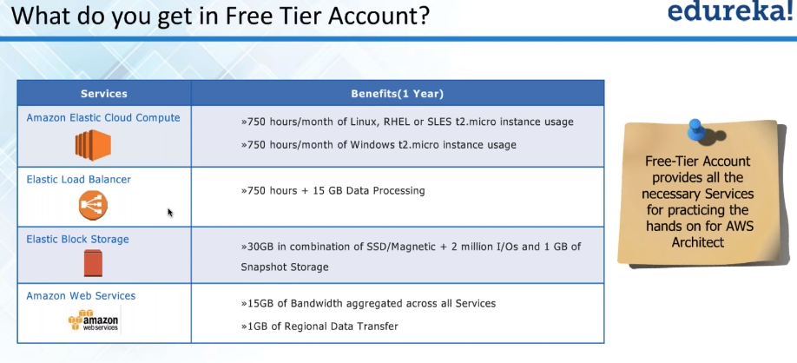

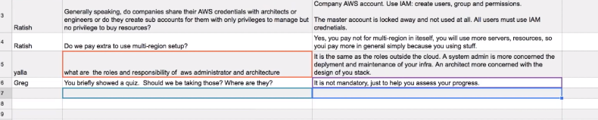

Cloud front is the content distribution network service.

